Turbofan RUL Project Group Study Report
Progress from dataset acquisition through FD001 and FD002 evaluation | 30 September 2026
This report gives the five-person team one shared explanation for tomorrow. It starts with the original NASA data, follows the transformations and model-selection steps, and ends with the FD001 and FD002 official-test results. It explains what the saved graphs mean and which evidence files to open. The wider FD003–FD004 comparison and detailed error analysis are reserved for the final review.

Project question and target
The project predicts an engine’s remaining useful life (RUL): the number of operating cycles left before the simulated failure threshold. It is a supervised regression problem because the answer is a number of cycles, not a class label. The data are simulated C-MAPSS turbofan histories, not records from operating airline engines.

What has been completed in order
Stage | Completed work | Why it matters
1 Data | Preserved the FD001–FD004 raw train, test and RUL files, README, archive and source notes. | The original input remains available for checking and reproduction.
2 Preparation | Named 26 fields; checked quality; derived training RUL; mapped official test answers. | Creates a trustworthy target without changing the raw evidence.
3 EDA | Reviewed engine lifetimes and sensor variation; saved tables and figures. | Established how trajectories vary before modeling.
4 Modeling | Engine-wise validation; compared four syllabus-aligned regressors. | Selects a method without mixing an engine across fitting and validation.
5 Testing | Refitted winners and evaluated unseen official-test engines. | Measures predictive error on held-out engines rather than training rows.

Original dataset at a glance
Each raw row contains an engine ID, a cycle number, three operating settings, and 21 sensor readings: 26 numeric columns in all. A training engine’s sequence continues to failure. A test engine’s sequence ends earlier; its answer file gives the true RUL at the last observed cycle. The files used for modeling are train_FD00X.txt, test_FD00X.txt and RUL_FD00X.txt, where X identifies FD001–FD004.
Show: data/raw/files/readme.txt and docs/DATA_DICTIONARY.md. One row represents one engine at one cycle; it is not one complete engine.

How the data became model inputs
The pipeline first parses the whitespace-separated text and assigns column names. It checks missing and infinite values, duplicates, engine-cycle uniqueness, data types and cycle order. For every training row, RUL is the engine’s final cycle minus that row’s current cycle. For official test evaluation, the supplied RUL vector is aligned with test-engine IDs.
The model retains sensors that vary enough in the fitting engines. It also adds one-cycle sensor changes and five-cycle rolling averages. Those features use the present and earlier cycles only; future readings cannot enter a prediction. Unit ID identifies a trajectory but is not a predictor. RUL and other answer or failure metadata are excluded from predictors. Ridge scaling is fitted on training data inside its model pipeline.
Example to explain: If a training engine ends at cycle 200, its row at cycle 150 has RUL 50 cycles. That target comes from the complete training trajectory; the model inputs at cycle 150 may use only readings available through cycle 150.

What each model does
Candidate | Plain language explanation | Why included
Median baseline | Always predicts the median training RUL; it does not learn sensor relationships. | Checks whether ML improves over a simple reference.
Ridge regression | Fits a weighted combination of input features; L2 regularization discourages extreme coefficients. | A simple regularized linear model.
Random Forest | Averages predictions from many regression trees built on varied training samples and features. | Captures nonlinear patterns through bagging.
Histogram Gradient Boosting | Builds regression trees sequentially so later trees correct errors left by earlier ones. | Tests a different nonlinear ensemble: boosting.

Why validation and testing are different
The code first reserves 20% of training engines for validation. It fits candidates on the other engines and checks each candidate at one partial-history point per validation engine. The lowest validation RMSE selects the candidate. Then the selected model is refitted on all training engines and predicts one RUL for each official test engine at its last available cycle. The official RUL answer files are used only to score those final predictions.
Reason: Validation chooses the model; official testing asks how it performs on different engines. Splitting individual rows instead would let early and late rows of the same engine appear on both sides, giving a misleadingly easy result.

FD001 model selection and test result
FD001 contains 100 training and 100 test engines, with one operating condition and one fault mode. The validation split held out 20 training engines. The table shows how candidate models compared before the official test answers were consulted.
Candidate | Validation MAE | Validation RMSE | Validation R²
Random Forest | 21.01 | 27.17 | -0.72
Histogram Gradient Boosting | 21.12 | 27.31 | -0.74
Ridge regression | 27.66 | 32.93 | -1.53
Median baseline | 43.95 | 47.51 | -4.26

Random Forest had the lowest validation RMSE, so it was selected for FD001. Its official-test result was MAE 21.21 cycles, RMSE 28.68 cycles and R² 0.52 across 100 test engines.

FD002 model selection and test result
FD002 has 260 training engines, 259 test engines and six operating conditions. A separate engine-wise split reserved 52 training engines for validation. Histogram Gradient Boosting had the lowest validation RMSE at 32.16 cycles; Random Forest followed at 33.14. After refitting, boosting achieved official-test MAE 20.27 cycles, RMSE 27.66 cycles and R² 0.74 across 259 test engines.

Scores the group must explain accurately
Subset | Selected model | Test MAE | Test RMSE | Test R²
FD001 | Random Forest | 21.21 | 28.68 | 0.52
FD002 | Histogram Gradient Boosting | 20.27 | 27.66 | 0.74

- MAE is the average absolute prediction error in cycles. FD002 is off by about 20 cycles on average in this test.
- RMSE also measures cycle error, but penalizes large misses more strongly. Lower MAE and RMSE are better.
- R² compares predictions with a mean-prediction reference on the same set. It is not an accuracy percentage and can be negative.
FD002 has the better official-test numbers in this particular comparison. The subsets contain different engines and operating conditions, so this does not prove that boosting is universally better than Random Forest. Validation R² was negative for FD001 (-0.72) and FD002 (-0.60), which also limits claims of stability from one split.

How to read the FD001 prediction graph
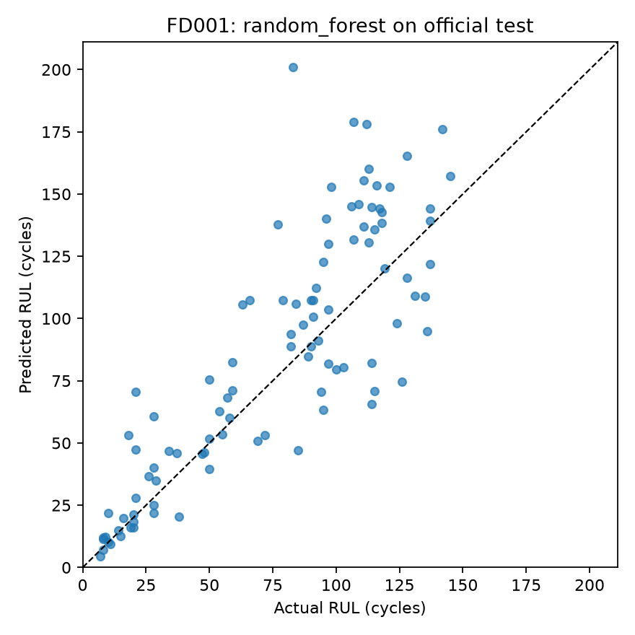
FD001 official test actual versus predicted RUL
The horizontal axis is true remaining cycles, taken from the official answer file. The vertical axis is the Random Forest prediction. Every dot is one of the 100 test engines. The dashed diagonal means predicted RUL equals actual RUL; a dot closer to it has a smaller error. Dots above the line overestimate life, while dots below underestimate it. The spread becomes visible at medium and high RUL, so the MAE must not be described as a guarantee for each engine.

How to read the FD002 prediction graph
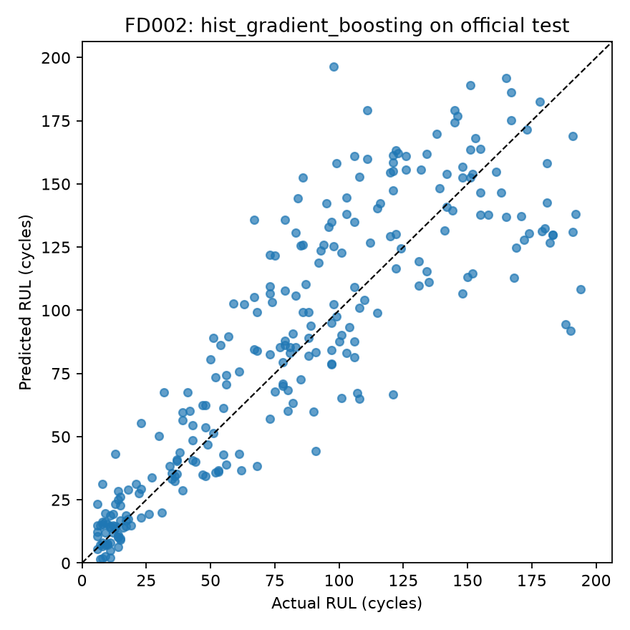
FD002 official test actual versus predicted RUL
The axes and diagonal have the same meaning as in FD001, but this graph contains 259 test engines and the chosen model is Histogram Gradient Boosting. Many low-RUL points gather near the origin. At higher true RUL, predictions spread around the diagonal; some are substantially above or below it. The graph therefore supports the numerical score while revealing individual errors that an average hides.

What the graphs do not prove
Neither scatter plot shows training accuracy, real-aircraft safety, or the exact time of a future failure. They show one prediction per held-out simulated test engine. A visually strong cluster near the diagonal can coexist with large errors for individual engines. Official-test performance should be reported together with validation limitations and the simulation caveat.

Five person preparation and presentation split
Use this division to prepare for tomorrow and confirm any historical contribution claims with one another before sending them outside the group. Each member should understand the complete pipeline well enough to answer a basic follow-up question.
Person | Section to lead tomorrow | Evidence to open and likely question
Soham | Overall project flow, experiment integration, model-selection decision and final score interpretation. | Open the study report, modeling protocol and result table. Explain why validation selects a model but test answers do not.
Hardik | Dataset identity, 26 raw fields, training versus test trajectories and RUL target. | Open the source README and data dictionary. Explain what one raw row represents.
Farhaan | Preprocessing checks, sensor selection and causal time-history features. | Open preprocessing summary and before-and-after samples. Explain why future sensor readings are excluded.
Sanjeet | The four candidate models and the FD001 validation comparison. | Open FD001 validation_metrics.csv. Explain Ridge, Random Forest, boosting and the median baseline.
Sparsh | FD001 and FD002 official-test graphs, metrics and limitations. | Open both prediction plots and test metrics. Explain axes, diagonal, MAE, RMSE and R².

Exact files to open
All paths below are relative to the project folder Turbofan_RUL_CMAPSS_25_30_Percent 2.
- Raw input and meaning: data/raw/files/readme.txt; docs/DATA_DICTIONARY.md; data/raw/files/train_FD001.txt.
- Preparation evidence: reports/PREPROCESSING_SUMMARY.md; reports/data_quality_summary.csv; reports/before_after/.
- Method and selection: docs/MODELING_PROTOCOL.md; train_models.py; reports/modeling/FD001/validation_metrics.csv; reports/modeling/FD002/validation_metrics.csv.
- Official tests and plots: reports/modeling/FD001/ and reports/modeling/FD002/, especially official_test_metrics.csv and official_test_actual_vs_predicted.png.

Boundary for this review
Stop the detailed walkthrough after the FD002 plot and its interpretation. The repository also contains FD003 and FD004 test runs and broader error analysis; save their full comparison, overestimation counts, and final synthesis for the last presentation. Those runs are already complete, so do not describe them as work that has not yet happened.

